Indoor Curve 4000x1000mm 2.6mm User Guide

Before using our products, please read this detail carefully and follow the instructions correctly for safe operation. Please keep this guide handy for future reference.
The display has been tested and pre-installed for 200hours and is free of defect at time of shipping.
Only ever change a module or parts under instruction on a work bench, open locks, remove tabs of security tape. Keep displays protective covers in case of requiring shipping later in original packaging.
Please be sure to always include this user manual in the packaging when transferring or transporting this product to a different location or customer.
ONLY EVER FOLLOW APPROVED SET UP DRAWINGS, CABLING DIAGRAMS AND SIGNED OFF SET UP.
THE DISPLAY HAS BEEN CALIBRATED AS BUILT AND SHOULD BE BUILT AS WAS APPROVED IN FACTORY.
WARNING: To reduce the risk of electric shock, do not perform any servicing other than that contained in the operating instructions unless you are qualified to do so by Reseller.
ALWAYS TURN OFF AND DISCONNECT THE MAINS WHEN SERVICING THE PRODUCT
These displays are heavy and should be moved and installed by at least two individuals.
You should first discuss a lifting method, set up an area that is clear from members of the public and safety barriered to avoid any contact or damage when lifting the products.
Do not attempt to move or install the product on your own, otherwise injury and/or damage may occur. When moving the display always check packaging for damage, hold the casing carefully with gloves and make sure you have a firm grasp around the product casing.
Do not tilt the displays in a different orientation to that which they have been designed.
When moving the product do not tilt or invert the display.
We recommend using an IP rated conduit for cabling as per our original design.
Any additional hanging points and installation method local to the structural engineer are not the suggestion of Reseller. We have therefore to pass our own testing standards separate to the specification made and passed ETL and included the material structural assessment.
Once installed switch off mains power, disconnect cables and all accessories and cables before moving or working on the display.
Refer to this guide for software start up and shutdown procedures.
Follow all warnings and cautions you have received in product training
Locate the product at least 1000mm away from heating and cooling vents.
Only locate the product in a well-ventilated area without obstructions to the sides and front and back of the displays.
Do not install the product or use near any heat sources such as radiators, heat registers, stoves, or other devices (including amplifiers) that produce heat.
Do not drop the display.
WARNING: It is recommended that this display is securely attached to an installation location only by the Reseller certified service personnel as per installation instructions.
Tipping, shaking, hanging from or rocking the display is dangerous and may cause injury.
The power outlet used to power this device should be readily accessible for fast disconnection in case of emergency and RCD Breaker with a 30mA breaker and rated correctly for the appliance.
No flame source, such as lighted candles or fire should be placed on the display.
Use the power cable provided. Connect the power cable with a protective safety (earth) ground terminal. A surge-protected power strip is recommended. Do not use standard plugs or wall outlets for installation use only.
Do not install the display in places subject to excessive mechanical vibration.
Do not place the display on an unstable surface, which could result in serious personal injuries and damage.
When disconnecting the power cable to service the display, isolate the mains power, do not pull or hold the display by the cables. Only hold underneath the display when removing it from its desired vertical hanging position.
Protect all cables and power cable from being walked on or pinched particularly at the point of entry to the gland, safely use armoured exterior conduit to protect the cable into the display along the cable run and the point where they enter the installation location for their desired use.
Always disconnect mains if you are not going to use it for an extensive period.
You can clean our displays with a microfiber cleaning cloth. The screen may be wiped with the cleaning cloth when the power is off. Never use alcohol, solvents, or ammonia-based liquids on this display. Do not use high powered pressure washers or any other cleaning products only a qualified Reseller service personnel can be authorised in safe cleaning of the products.
On receiving the display. First, wash hands, wear gloves to avoid excessive grease to powder coating.
Place always the display in its correct orientation at a safe location that has been secured away from the public. With a Reseller Service person in the location, remove packaging be careful to not pull-on cable glands, do not ever use glands to hold the display.
Safely store for the duration of the build packaging in case any parts need to be sent back to Reseller.
It is very important the packaging is not disposed of until the display is commissioned and suggest to be returned at cost to be reused or recycled under our strict zero waste management policy.
Should you wish to dispose of the displays at any time please contact Reseller for collection and subsequent recycling under the WEEE Directive all Reseller products must only be returned for disposal. At no time can any items be landfilled or sent to be scrapped.
Before you open any product, cases or begin work to unpack boxes make sure you have a work bench area, the installation area is cordoned off and you have the supportive structure for the display tested and rated to take the total weight of the product and as it is installed. Arrange for the power distribution to be tested prior to use. Correctly identify the equipment to lift the items into position. Always work to local regulations.
The attached user guide is designed to support professional installation use and is not for domestic or another resale. The product is made with a power cable, for the purposes of testing to check functionality prior to installation. At this time, we have passed the product through manufacturers 1-year portable appliance testing. This product must be throughout the installation be installed with a qualified electrician. We recommend 16-amp Ceeform, Seetronic connector. This cable has been visually inspected.
The product is to be tested prior to use and at point of delivery any queries raised.
Resellers are ultimately responsible for safe installation and the design requested.
On acceptance of delivery the customer accepts RMA warranty repair and return is only on basis of confirmation of an RMA number from Reseller with the subject heading RMA and product serial number issued at time of assembly. It is a return to base warranty for the items which will be sent with a warranty statement.
You must detail upon delivery, any damage, the type of fault, location of fault and any damages on receipt of the delivery and immediately notify the shipper and Reseller.
Each display is supplied with a player and processor which has a data cable connection to screen from the player processor supplied. This will have a serial number and be colour coded and packaged with each order. These player processors have been flashed with the software, custom FPGA, RCFGX file, .scr file.
A reset switch on the box is only to be used when instructed. NEVER Factory default, send RCFGX files without a remote login agreement to the operations director.
You have also the correct amounts of structural wall mount and a small selection of spare metal work.
The Power and data cables are to be installed safely to the display.
The set-up has been preinstall tested for 200 hours without defect and has no damage upon point of shipping.
Refer all servicing to qualified service personnel. Do not remove the front cover or back.
Servicing your own display can be dangerous to you and will void the warranty.
Store all small accessories, packaging and parts out of the reach of children.
The below instructions are a guide to help ensure image quality over the lifecycle warranty of the display.
Failure to follow these instructions may affect the warranty.
In case of emergency such as fire or electric shock caused by damage to the product, immediately contact Reseller and the proper emergency services in your area to safely manage this incident.
If any part is broken, do not use, handle with care, contact Reseller for a qualified service representative to assist you.
Use properly rated electrical voltage. Use of non-rated voltage may cause fire, electric shock and severe damages to the product.
Do not open the display ever in the exterior with the power on under any circumstances. High voltage inside of this product may cause electric shock.
Do NOT climb on the product.
Do NOT, under any circumstances, modify, copy or disassemble this product.
It is vital you do not attempt to make any changes to the design of the product as it may cause fire, electric shock, or severe damages to the product. Also, any unauthorized modifications made to the product automatically void product warranty and could begin legal action.
Any severe physical impact on the product may cause certain components to fall out of place within and break, which may cause fire or electric shock. In such event, do not operate the product. Disconnect the power, contact the manufacturer for support who will arrange a Reseller service personnel to manage the replacement for you.
Periodically of every 6 months we suggest a booking with our engineers to arrange a paid for service call to clean, manage and inspect the display with a Reseller qualified service personnel to ensuring proper and safe operation of the product. You will need to pay for the rate for the engineer, food, accommodation, travel and per diem per day on site.
Do NOT touch ever the metal parts of electrical plugs, wiring or open the display outside ever with bare hands.
Always make sure to consult a qualified NICEIC electrician for installation.
In case of product malfunction or unusual events such as electrical burning smell, smoke, or loss of content signal due to internal overheating, immediately turn off and contact Reseller.
Inventory Asset Registration is included with your shipment as a guide to what is in each box.
Please keep the plastic bags and Silica for safe transport. Keep a clear space when using LED Displays around the place you are rigging to.
Always refer to local safety advice and your assigned structural engineer who must be appointed by all installers of LED display and supersede any guide below. The product has been made brand new for use.
The cables supplied should be installed with a qualified electrician supervising the power management into the local power source.
Use your structural engineers advice to install the product safely and create your own method statement.
Set up a clear, dust free location to prepare the product for installation.
DO NOT STACK MODULES OR DISPLAYS ON TOP OF EACH OTHER. KEEP THEM PACKAGED CORRECTLY UNTIL INSTALLATION
Always check power is the correct voltage, amps and there is no instability with power. Make sure the room is dry and well air conditioned. DO NOT WORK IN A HUMID ENVIROMENT.
You are required to use a professional rigging company for all hanging systems. All LOLER/OSHA 29 CFR 1926/1910 should be followed or lifting and rigging professional advice sort for the use of hanging displays.
When using a ground support structure use the appropriate ballast calculator and over height of 3 meters consult a structural engineer on all staging and screen rigging.

Installation Instructions:
Step 1
Lay the panels in the foam tray in a clean area and test each one to make sure no faults by pressing the test button on the back of panel(Fig 1).

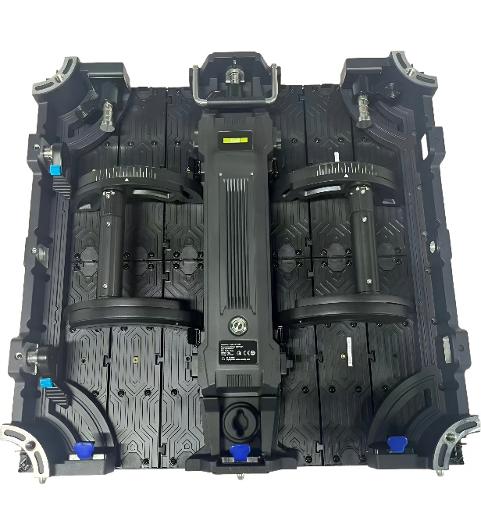

Fig1.

Step 2
Each panel has a serial number from CBUSVAIC2.6001 to CBUSVAIC2.6008. When assembling the panels start with 001 then 002 , 003, 004, 005, 006, 007 and 008 in a circle (Fig 2)
Connect the power and data link cables from panel 001 through to panel 008.
Fig 2.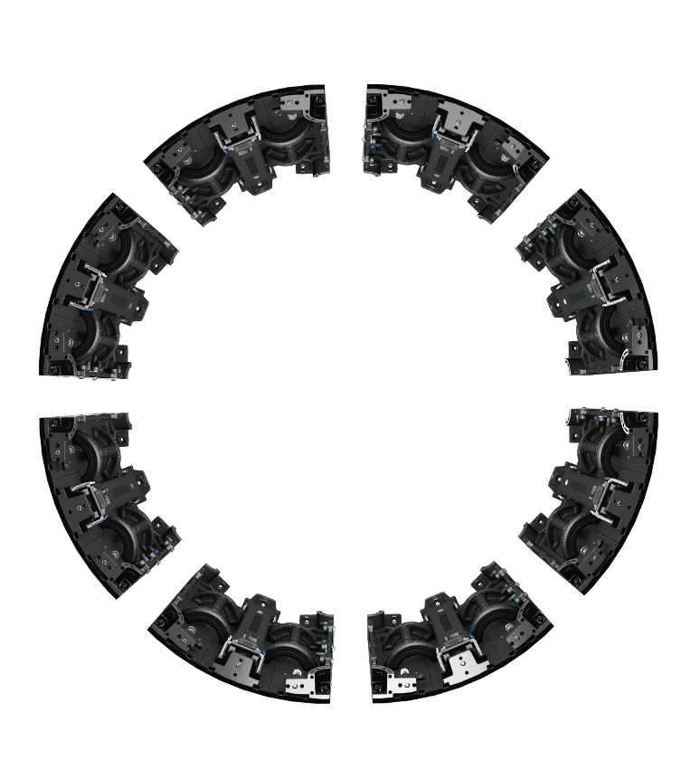

Step 3

Attach the 2 in 1 hanging bars (Fig 3) onto the circle display(Fig 4). Start from 001 then 003 , 005, 007 (every other panel)
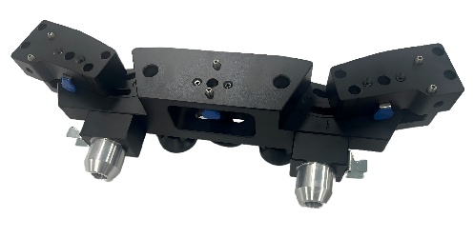
Fig 3.

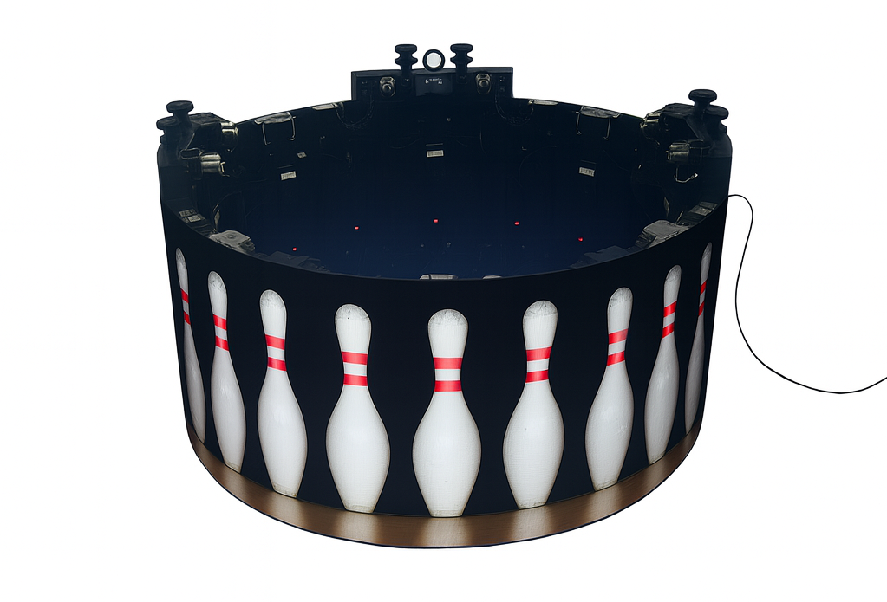
Fig 4.

Step 4
Connect main power and data cables to panel 001.
Step 5
Plug in the data cable into the CBA200 Player.
Connect the CBA200 player to local Network.
Login Colorlight Cloud
Username: CBUSVAIC26001
Password: Cb123456!
Display Resolution: 1536x192 pixels
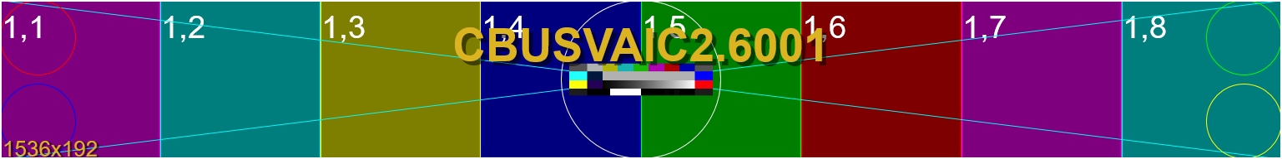
WARNING RISK OF ELECTRIC SHOCK
To reduce the risk of electric shock do not disassemble the unit under any circumstances when powered.
No user serviceable parts inside. All product services should be done by Resellers certified service personnel. Switch off at RCD breaker, disconnect mains and safely package and return unit for warranty return to base RMA. Do not change diodes, cables, or parts in the premade display without first authorisation. Make sure you disconnect mains, should any parts be damaged shield the damage, wrap safely and return under RMA instructions do not allow moisture to enter the display.
If display has been damaged it must be returned to our dedicated service centre. Panel replacement is only possible by factory. This is done by putting on a specialist work bench. It is vital to the IP integrity that no attempt be made to maintain electronics or attempt to service a product in an environment the product is installed in. Opening this display or changing glass without an approved Reseller certified service personnel will invalidate warranty.
Always make sure the power supply is as per the requirements of the product stated and drawings provided. Always consult a local qualified electrician to make sure power is safe to use.
Once a qualified electrician has confirmed the power is safe to use and meets spec.
Plug in the power and data to the first cabinet as per drawings supplied.
Check the product plays content and has no pixel failure.
Repeat this process to test the whole order and no damages.
Set out a clear space table and workspace for all the modules to be removed and free of any dust.
How to remove modules safely.
Disconnect the power to the display. Isolate mains and wait for all led indicators to power down to confirm electronics no longer hold power.
Create a clean work bench area that is well ventilated and free of dust.
You will see on the reverse numbers above the Power and Data Unit that state its serial number and the module Chassis ID example: CBUSVAIC2.6001A will be the top module of the display.
Do not mix modules into different locations. It is vital the modules remain in the correct positions.
Do not change modules for spares. Firstly note the required replacement Module ID and the spare module to be changed. This will be required by the remote service engineer to recall any parameters for calibration. All modules have been precalibrated at the factory with colourspace, brightness and data saved.
Do not mix serial numbers, modules or screen batches they are all calibrated correctly and made to work correctly as per wiring.
Once tested using the removal tool remove the modules to attach the frames to the wall mount.
Remove the modules using the service tool and safely store with them face down in the spare module foam packaging. For RMA return, package with diodes, IC driver, PSU, test rig and masks in antistatic bubble wrap with no free space in the packaging. Email Reseller for a return number and Shipping address.
De rigging the product
Collect your packaging from storage. Unpack the packaging.
Use the same packaging as supplied, taking care to use the supplied foam inserts, make sure each section is as it was sent. Use the Silica gel when packaging modules or any electronic parts.
RMA Returns and packaging.
Safely store the packaging and all parts near to your location.
Should you need remote support email Reseller and will be set a time with the correct engineer to support your ticket. Tickets are answered within 24 hours.
Should an item be required to be returned please make sure you use the correct process.
Firstly confirm the serial number of the item. Email a request for RMA support to Reseller.
Once the RMA form is received an RMA number and return address issued. Depending on the RMA requirement there shall be a RMA delivery address assigned.
You will be sent a form, once the form is received fill out with serial number, reason for repair, location of the return delivery address. Email this form to Reseller.
Once the RMA is approved you will be sent back the commercial invoice, shipping address and RMA paperwork.
Print a copy of this form and commercial invoice to place into the product packaging.
Make sure you use the spare parts anti static bag with silica gel the items. Use Bubble wrap and package in triple wall cardboard the return item. Place inside the box the RMA form and label clearly on the box the return address you have been shipped. Make sure there is no free space in any boxes.
For led module returns, please send the module, diodes, IC, receiver card, Hub Card, Masks and flash button which shall be in your spares package.
Once ready you will then need to arrange postage and be sent a commercial invoice to ship with the goods and state the right HS Code and the return value of $50.
Make sure at all times within your possession all items, electronics and spares are stored in an air conditioned location with Silica Gel.

